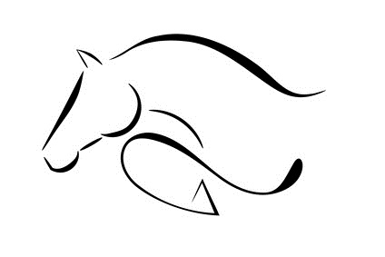
D & F ARENA EVENTING
CLASS

ONE
Individual
HEIGHT
65CM
COURSE WALK
8:45-9am
9:39-9:49am

NO | M. | RIDER | HORSE | SCORE |  | TOTAL | TIME | PLACE
 |  |  |  | SJ | XC
1 |  | ISABELLA GRACE | PATSY |  |  | E
2 | Y | RACHEL HELME | MARIE | 0 | 0 | 0 | 54.13 | 1ST
3 |  | AMBER BELLIS | GLENDALE RABBONI | 0 | 0 | 0 | 43.13 | 3RD
4 |  | KATIE DAWSON | PIG |  |  | E
9 |  | CAROLYN BELL | MATILDA | 0 | 12 | 12 | 84.82 | 4TH
10 |  | BETH HOWATSON | NUTTY | 0 | 0 | 0 | 37.77 | 2ND
11 |  | MADI HAERR | FUSHIA |  |  | E
12 |  | CHARLEY-ANN | PAIGE |  |  | E
13 |  | LUICA McPHEARSON | VEGAS | 0 | 0 | 0 | 37.16 | 1ST
14 |  | LOUISA HARE | ANNEST |  |  | E
15 |  | CELYN OWEN | ROCKET |  |  | E
16 |  | SCARLETT OWEN | SWEEP | 4 | 0 | 4 | 45.03 | 5TH
17 |  | MILLIE McLARDIE | DIESEL |  |  | E
18 |  | SIWAN WILLIAMS | HEIDI | 0 | 12 | 12 | 91.92
19 |  | HARVEY JONES | DASHER | 4 | 0 | 4 | 42.00 | 4TH
20 |  | COURTNEY EDWARDS | REBEL |  |  | E
21 | Y | RACHEL HELME | CERYS | 0 | 8 | 8 | 62.34 | 3RD
22 |  | JOANNE | BLUE BELLS GIRL | 0 | 4 | 4 | 70.06 | 2ND
23 |  | LILLIE McQUE | RIVERSTOWN | 4 | 0 | 4 | 56.10
25 |  | MADDISON TAYLOR | DYLASAN TARAN LLIGAR | 4 | 0 | 4 | 49.64 | 6TH

----- UNDER 18 YEARS OLD ---

