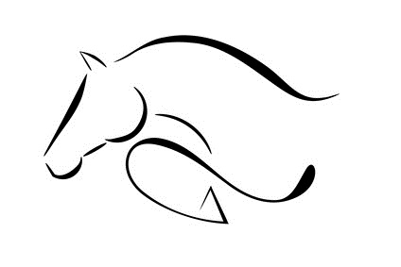
D & F ARENA EVENTING
CLASS

TWO
Individual
HEIGHT
75CM
COURSE WALK
10:30 – 10:45
11:33 – 11:43

NO | M. | RIDER | HORSE | SCORE |  | TOTAL | TIME | PLACE
 |  |  |  | SJ | XC
26 |  | LOUISA HARE | ANNEST | 0 | 4 | 4 | 60.98
27 |  | HARVEY JONES | DASHER | 4 | 0 | 4 | 44.69 | 4TH
28 |  | ELIA DAVIES | DUMBLEDORE | 4 | 8 | 12 | 53.37
29 |  | JACQUI ASHFORTH | RORY |  |  | E
30 |  | CELYN OWEN | ROCKET | 0 | 12 | 12 | 75.90
31 |  | MILLIE McLARDIE | DIESEL |  |  | E
32 |  | SCARLETT OWEN | SWEEP | 0 | 0 | 0 | 46.32 | 1ST
33 |  | LUCIA McPHEARSON | VEGAS | 0 | 8 | 8 | 55.55
34 |  | SIWAN WILLIAMS | HEIDI |  |  | E
35 |  | COURTNEY EDWARDS | REBEL | 20 | 4 | 24 | 62.80
36 |  | BETH HOWATSON | NUTTY | 4 | 0 | 4 | 38.15 | 3RD
37 | Y | LILLIE McQUE | RIVERSTOWN | 0 | 0 | 0 | 52.43 | 2ND
39 |  | COLETTE TAMBLYN | INCA | 0 | 4 | 4 | 50.79
41 |  | MADDISON TAYLOR | DYLASAN TARAN LLIWGAR | 8 | 4 | 12 | 48.94
42 | Y | HEIDI O’BRIEN | BILL | 0 | 4 | 4 | 45.55 | 4TH
43 |  | JACK HEWITT | BASIL | 0 | 4 | 4 | 55.39 | 6TH
44 |  | KIRSTEN ROBERTS | GOLYGFAR NEO | 4 | 0 | 4 | 47.63 | 5TH
45 |  | CATRIONA DUFFY | SERGEANT PEPPER | 0 | 8 | 8 | 40.77
47 |  | NATALIE ROGERS | SKYE |  |  | E
48 |  | GEORGINA LOMAS | ROCKABILITY | 4 | 0 | 4 | 48.82 | 6TH
49 |  | PHILIPPA BROOKING | JIGSAW | 4 | 0 | 4 | 49.81
50 |  | SUZY LLOYD | PHOEBE | 0 | 16 | 16 | 87.62
51 |  | JANET FREEMAN | GINGER | 4 | 0 | 4 | 43.19 | 3RD
52 |  | JULIET JAMES | COMET |  |  | E
53 |  | LOUISE JONES | CLOUD | 0 | 4 | 4 | 64.94
54 |  | LOUISE JONES | JACK | 0 | 0 | 0 | 49.65 | 2ND
56 | Y | FAYE JONES | KODA DAKOTA | 0 | 4 | 4 | 46.73 | 5TH
57 |  | BETH DAVIES |  |  |  | E
58 | Y | EMILY O’BRIEN | MILLER | 0 | 0 | 0 | 39.55 | 1ST
59 | Y | HEIDI O’BRIEN | SCOTTY | 4 | 4 | 8 | 58.43
60 |  | JACK HEWITT | PIGEON |  |  | E
61 |  | LOUISE | CRWT | 0 | 12 | 12 | 55.13
120 |  | CATLYN WROE |  |  |  | E

----- UNDER 18 YEARS OLD

